**NUMERICAL ANALYSIS**

**\*BISECTION METHOD**

**1. REGULA-FALSI METHOD**

**2. NEWTON-RAPHSON METHOD**

**3. GAUSSIAN ELIMINATION (DIRECT)**

**4. GAUSS JORDON METHOD (DIRECT)**

**\*GAUSS JACOBI METHOD (ITERATIVE)**

**5. GAUSS- SEIDEL METHOD (ITERATIVE)**

**6. NEWTON'S (FORWARD AND BACKWARD) INTERPOLATION**

**\*NEWTON'S DIVIDED DIFFERENCE**

**7. LAGRANGE'S INTERPOLATION**

**8. TRAPEZOIDAL RULE**

**\*COMPOSITE TRAPEZOIDAL RULE**

**9. SIMPSON'S 1/3rd RULE**

**10. SIMPSON'S 3/8 RULE**

**11. GAUSSIAN QUADRATURE FORMULA**

**\*WEDDLE'S RULE**

**12. EULER'S METHOD**

**\*MODIFIED EULER'S METHOD**

**13. RUNGE KUTTA METHOD**

**14. NUMBER SYSTEMS & OPERATIONS**

**15. BOOLEAN ALGEBRA- LOGIC GATES, TRUTH TABLES, NORMAL FORMS**

**16. ALGORITHMS AND FLOWCHARTS**

**\*BISECTION METHOD**

*NO QUESTIONS SINCE 2010.

**1. REGULA-FALSI**

**1. 8b 2018 IFoS**



**2. 5b 2010 IFoS**



**2. NEWTON-RAPHSON METHOD**

**1. 5b 2020**

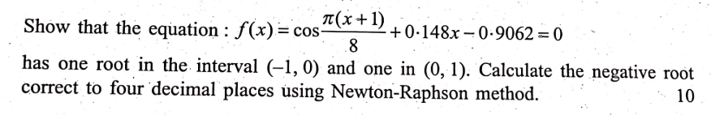

**2. 5b 2020 IFoS**



**3. 5b 2019**



**4. 7a 2017 IFoS**



**5. 7b 2016 IFoS**



**6. 5b 2014**



**7. 5a 2013 IFoS**

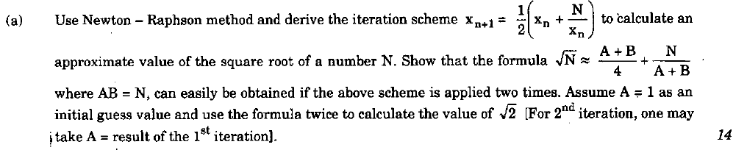

**8. 5b 2012**

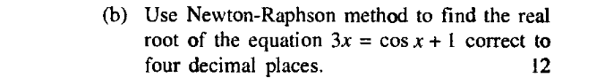

**9. 6c 2011 IFoS**

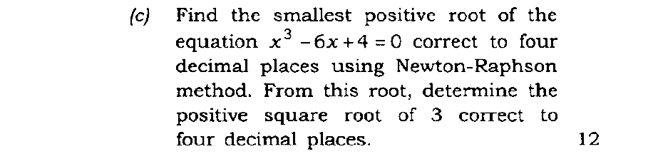

**10. 5c 2010**

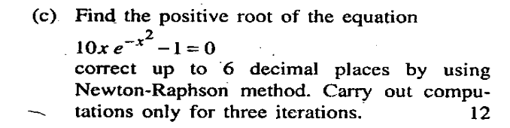

**3. GAUSSIAN ELIMINATION (DIRECT)**

**1. 8c 2020 IFoS**

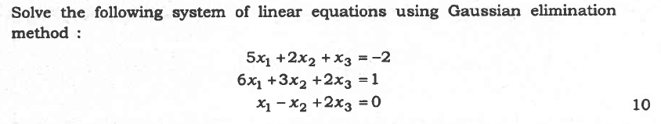

**2. 7b 2014 IFoS**

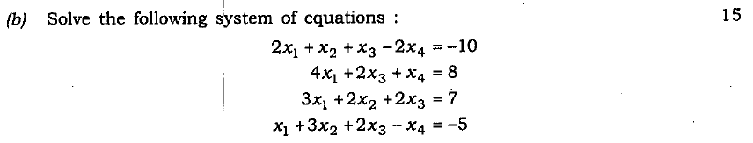

**4. GAUSS JORDON METHOD (DIRECT)**

**1. 6b 2019 IFoS**



**2. 5b 2017**

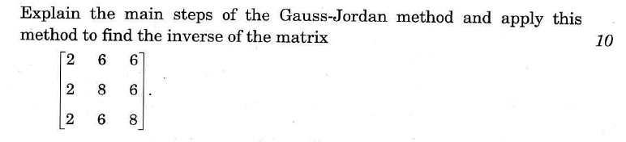

**\*GAUSS JACOBI METHOD (ITERATIVE)**

**1. 5c 2011 IFoS**

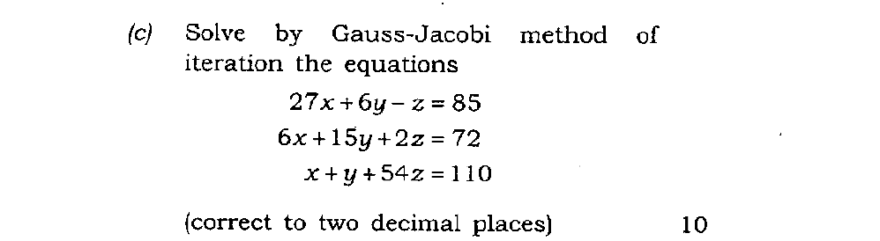

**5. GAUSS- SEIDEL METHOD (ITERATIVE)**

**1. 6b 2020**

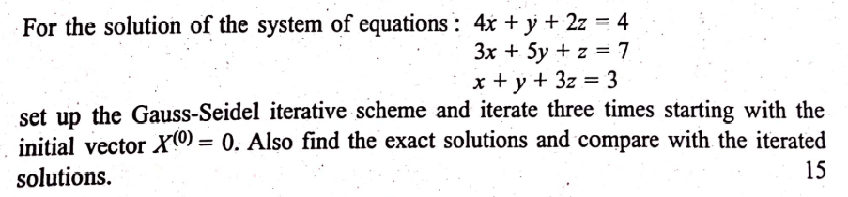

**2. 7b 2019**

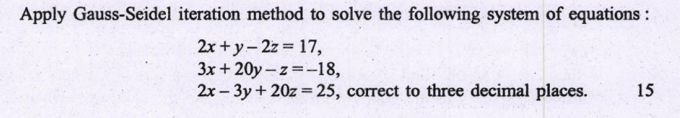

**3. 8b 2015**

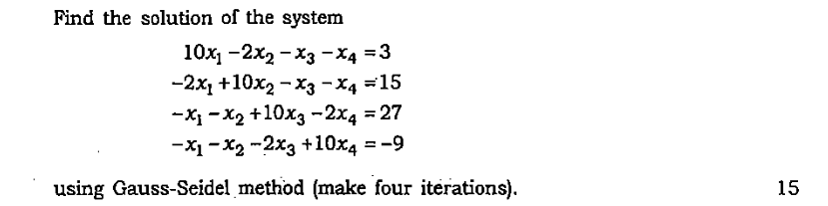

**4. 6a 2015 IFoS**

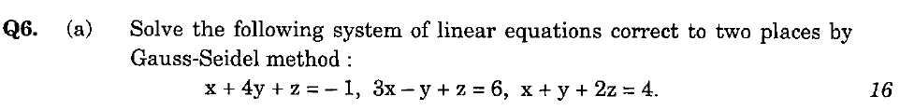

**5. 6b 2014**

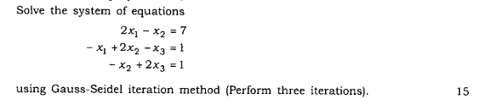

**6. 6c 2012**

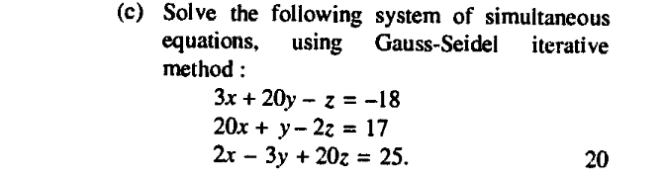

**7. 7b 2012 IFoS**

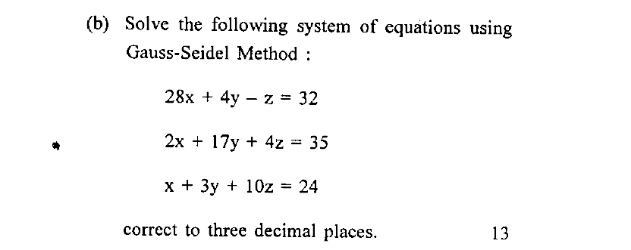

**6. NEWTON'S (FORWARD AND BACKWARD) INTERPOLATION**

**1. 5b 2019 IFoS**



**2. 5b 2018**



**3. 5c 2013**

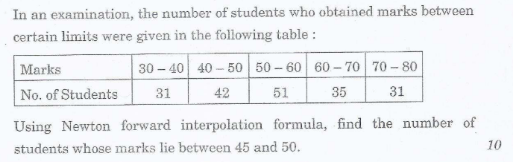

**\*[Newton's divided difference formula]**

**1. 7a 2012**

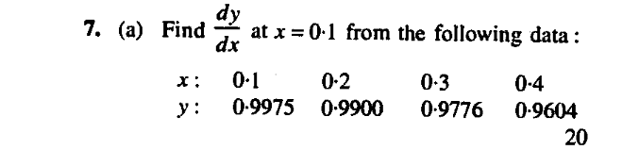

**2. 7c 2011 IFoS**

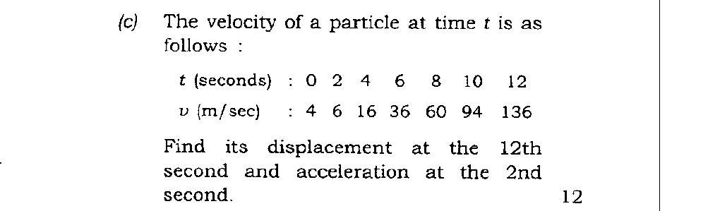

**7. LAGRANGE'S INTERPOLATION**

**1. 8b 2020**

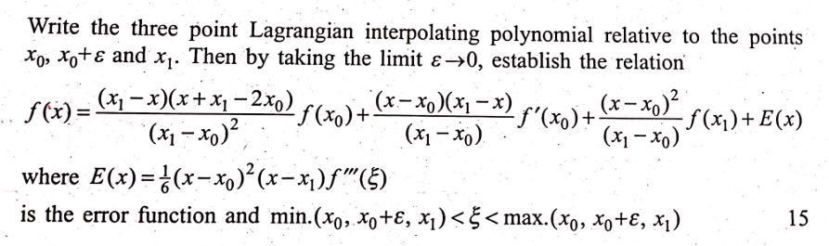

**2. 6b 2020 IFoS**

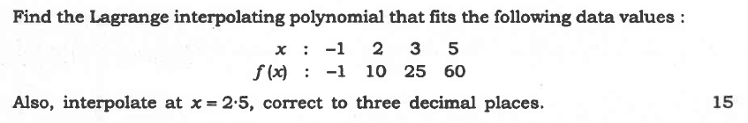

**3. 6b 2017**

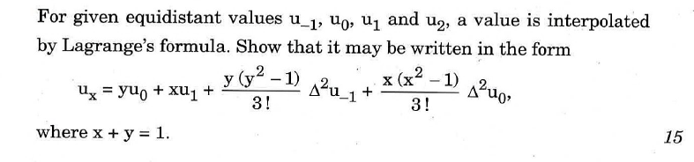

**4. 6c 2016**

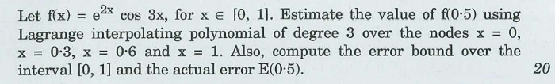

**5. 5d 2016 IFoS**



**6. 6c 2015**

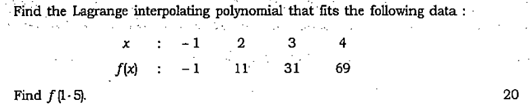

**7. 5b 2015 IFoS**

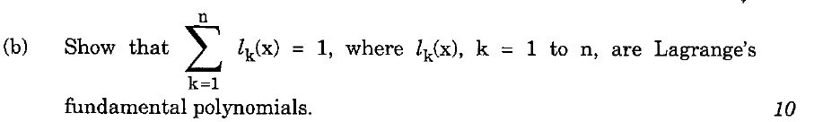

**8. 5a 2014 IFoS**

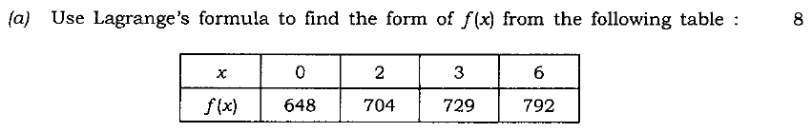

**9. 6c 2014 IFoS**

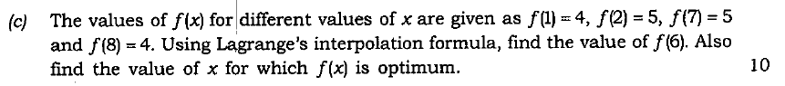

**10. 5a 2012 IFoS**

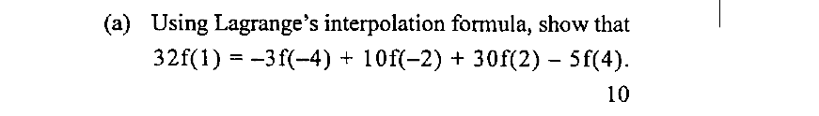

**11. 5b 2011 IFoS**

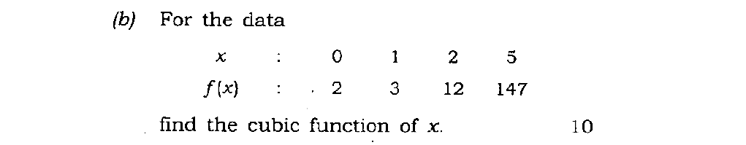

**12. 7c(ii) 2010**

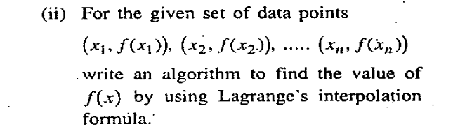

**13. 6a 2010 IFoS**

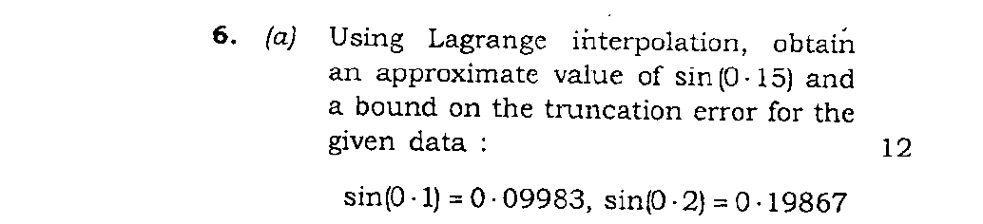

**14. 7c 2010 IFoS**



**8. TRAPEZOIDAL RULE**

**1. 8b 2020 IFoS**

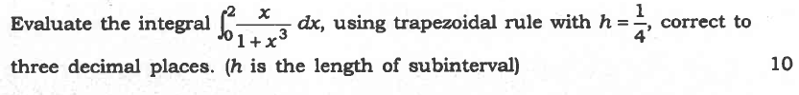

**\*COMPOSITE TRAPEZOIDAL RULE**

**1. 5d 2017 IFoS**



**9. SIMPSON'S 1/3rd RULE**

**1. 5c 2019 IFoS**



**2. 5d 2018**

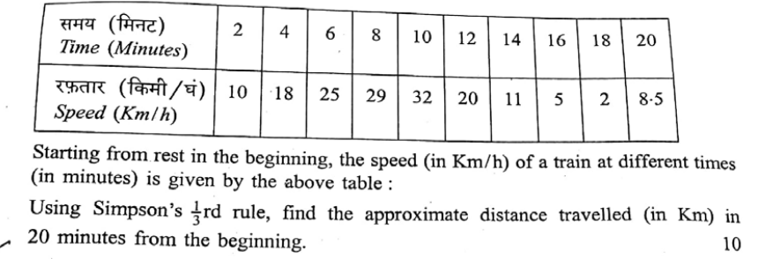

**3. 7b 2018 IFoS**



**4. 7b 2017 IFoS**



**5. 7a 2016 IFoS**



**6. 7c 2013**

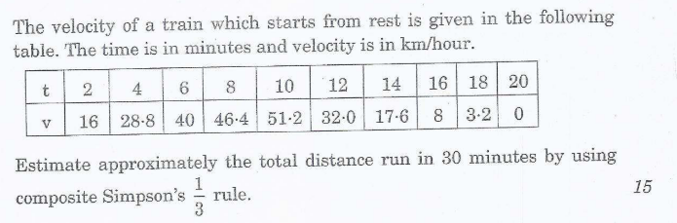

**7. 6c 2012 IFoS**

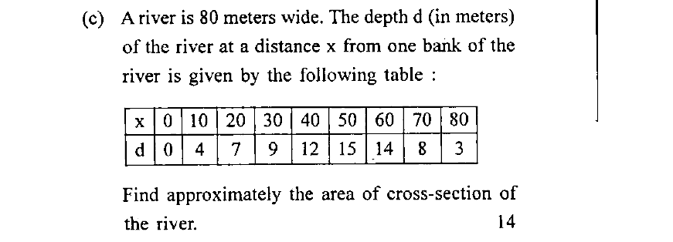

**8. 5c 2011**

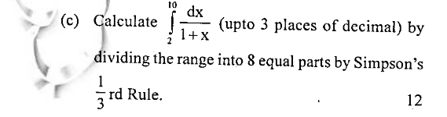

**9. 7a 2011**

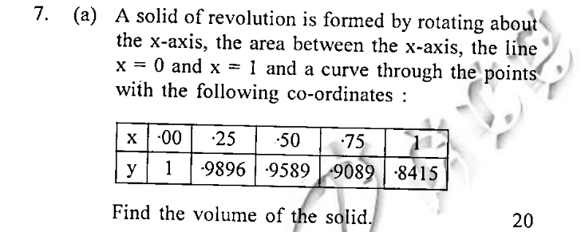

**10. 7c 2011 IFoS**



**11. 7b 2010**

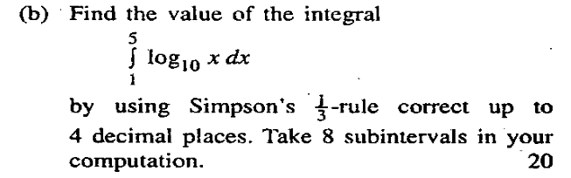

**10. SIMPSON'S 3/8 RULE**

**1. 7b 2017**

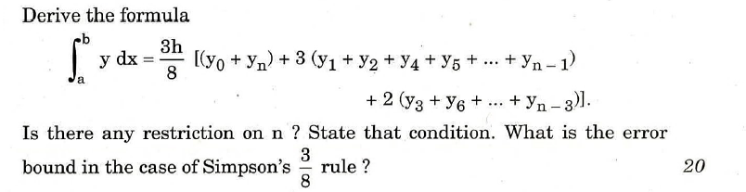

**11. GAUSSIAN QUADRATURE FORMULA**

**1. 7b 2020**

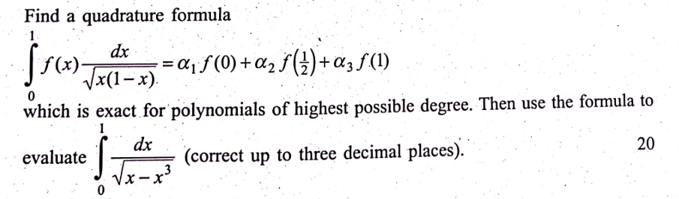

**2. 8c 2019 IFoS**



**3. 7b 2018**

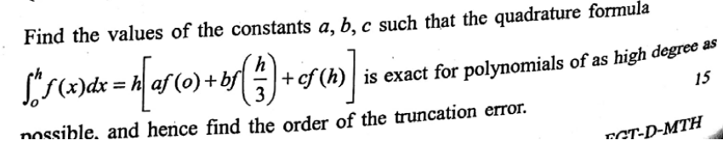

**4. 7c 2016**

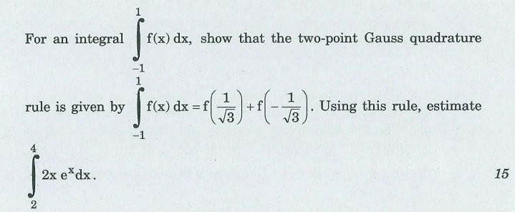

**\*WEDDLE'S RULE**

**1. 5b 2018 IFoS**



**12. EULER'S METHOD**

**1. 7b 2013**

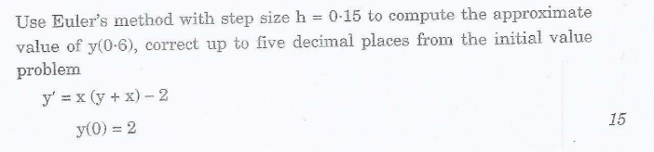

**\*MODIFIED EULER'S METHOD**

**1. 7c 2017 IFoS**



**2. 8c 2012 IFoS**

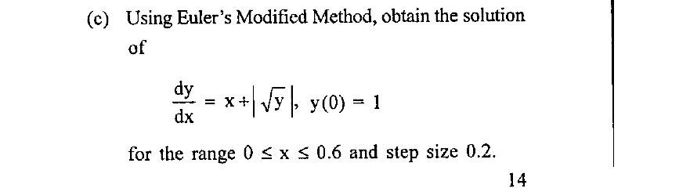

**13. RUNGE KUTTA METHOD**

**1. 5d 2019**

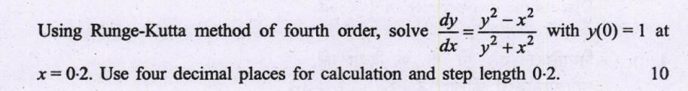

**2. 7a 2019 IFoS**



**3. 6b 2018 IFoS**



**4. 7c 2016 IFoS**



**5. 7b 2015**

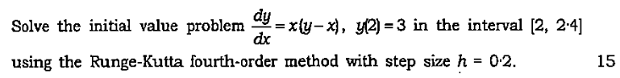

**6. 7c 2015 IFoS**

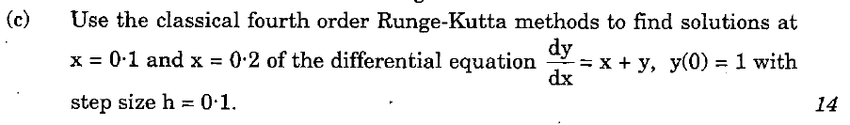

**7. 6c 2014**

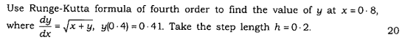

**8. 8a 2014 IFoS**

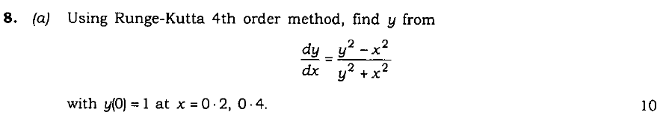

**9. 8b 2013 IFoS**

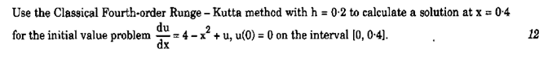

**10. 8b 2010 IFoS**



**14. NUMBER SYSTEMS & OPERATIONS**

**1. 5c 2020 IFoS**

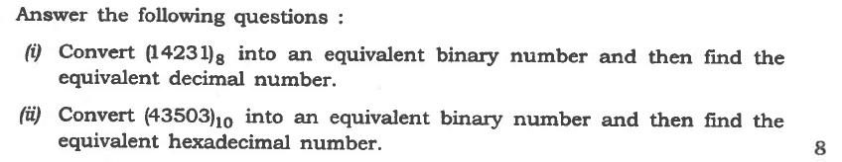

**2. 6a 2019**

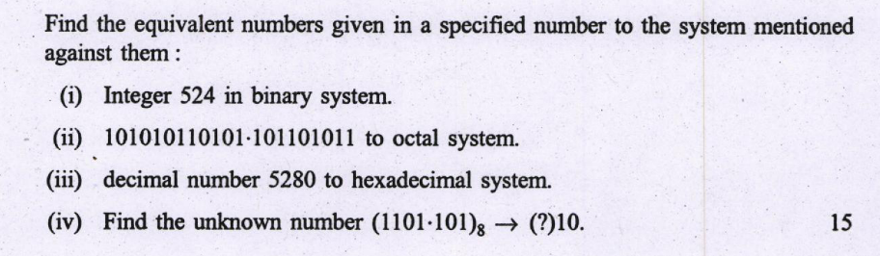

**3. 6b 2018**

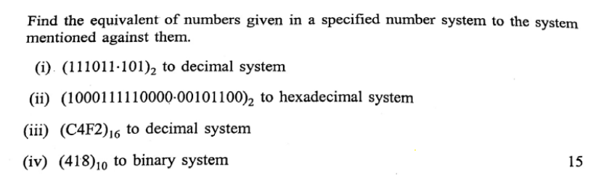

**4. 7c 2018 IFoS**



**5. 7d 2017 IFoS**



**6. 5d 2016**

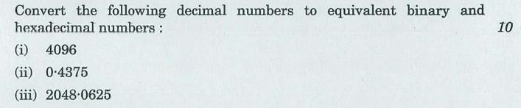

**7. 5a 2015 IFoS**



**8. 6b 2013 IFoS**



**9. 5d(i) 2011**



**10. 7c(i) 2010**

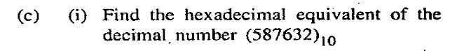

**11. 5c 2010 IFoS**

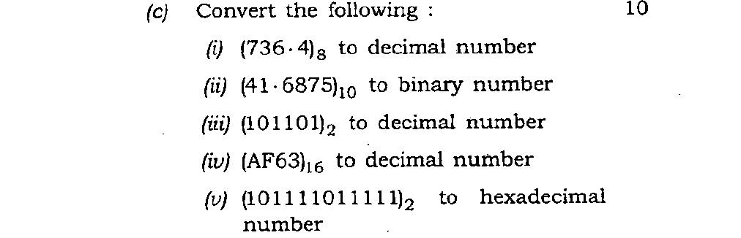

**15. BOOLEAN ALGEBRA- LOGIC GATES, TRUTH TABLES, NORMAL FORMS, LOGIC CIRCUITS**

**1. 5c 2020**

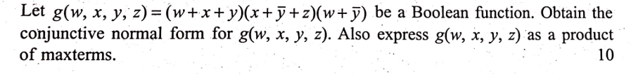

**2. 8a 2019**

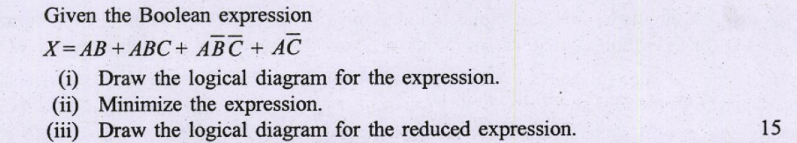

**3. 8a 2018**

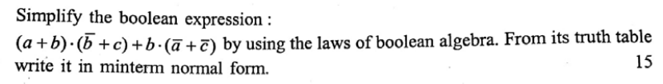

**4. 5c 2017**

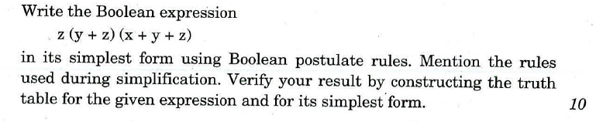

**5. 8c 2016**

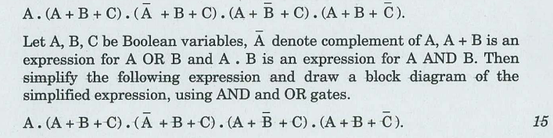

**6. 5c 2015**

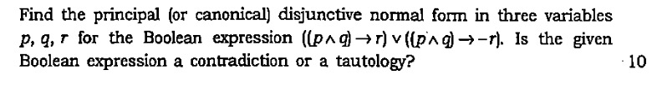

**7. 5d 2014**

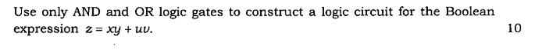

**8. 8b 2014**



**9. 5d(ii) 2011**

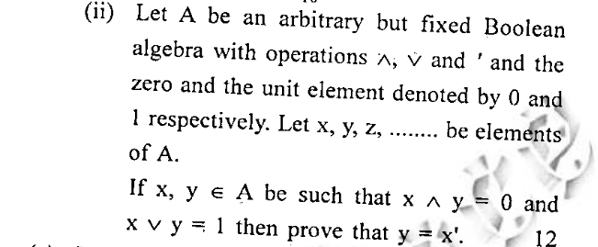

**10. 7b 2011**

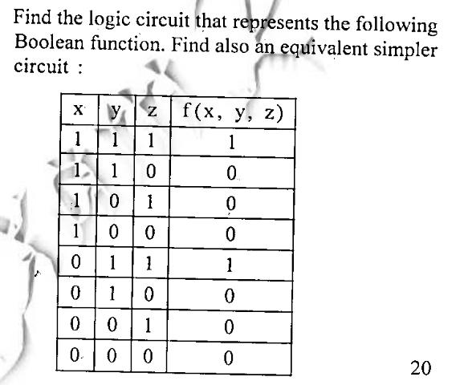

**11. 5d(i) 2010**

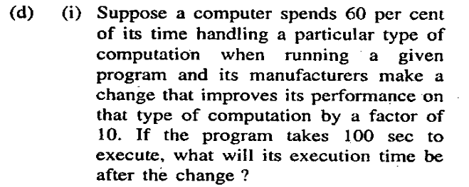

**12. 5d(ii) 2010**

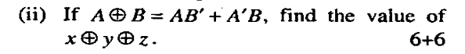

**13. 7a 2010**

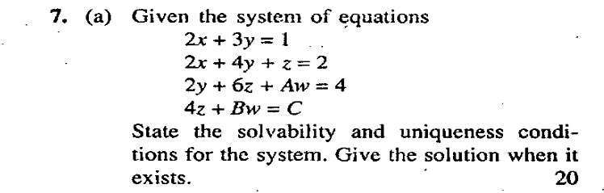

**14. 7c(iii) 2010**

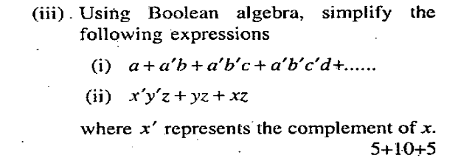

**16. ALGORITHMS AND FLOWCHARTS**

**1. 7a 2020 IFoS**

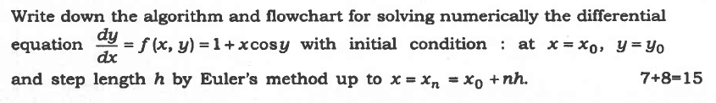

**2. 5e 2019**

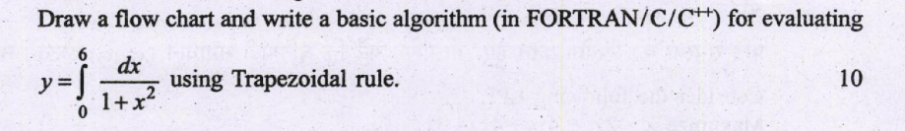

**3. 8b 2019 IFoS**



**4. 5e 2018**



**5. 5c 2018 IFoS**



**6. 6d 2018 IFoS**



**7. 8b 2017**

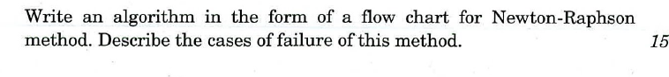

**8. 5b 2017 IFoS**



**9. 5c 2016 IFoS**



**10. 8a 2015 IFoS**



**11. 7b 2014**



**12. 5b 2014 IFoS**

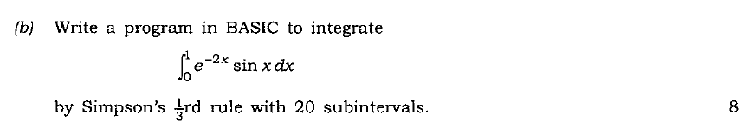

**13. 6d 2014 IFoS**



**14. 7a 2013**

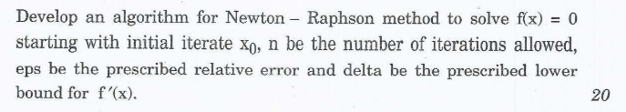

**15. 7b 2013 IFoS**



**16. 8c 2013 IFoS**



**17. 5c 2012**

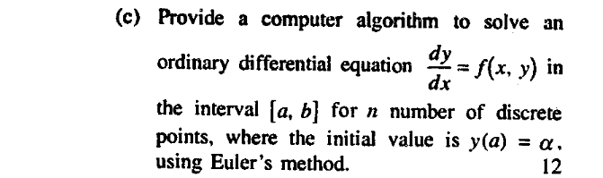

**18. 5c 2012 IFoS**

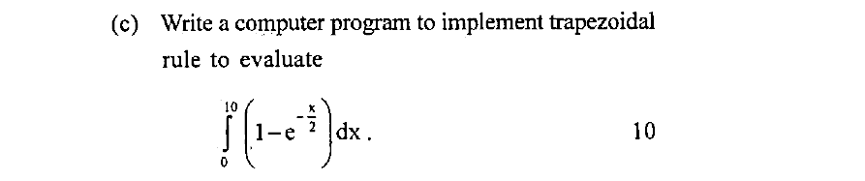

**19. 7c 2012 IFoS**



**20. 7c 2012**

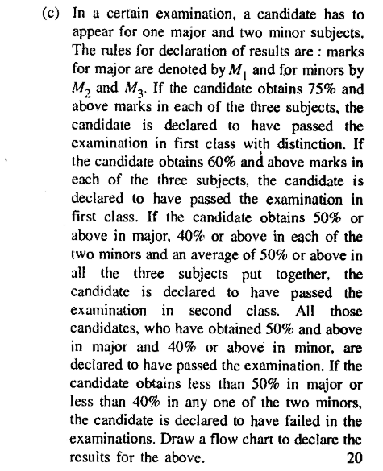

**21. 7c 2011**

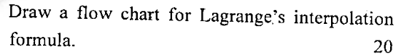

**22. 8b 2011 IFoS**

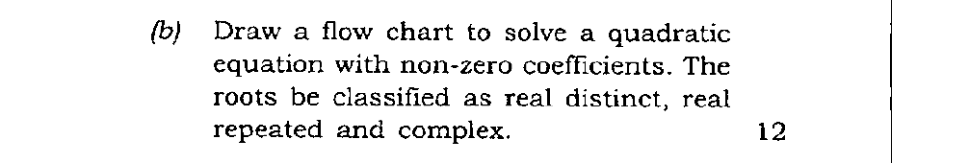

**23. 6b 2011 IFoS**

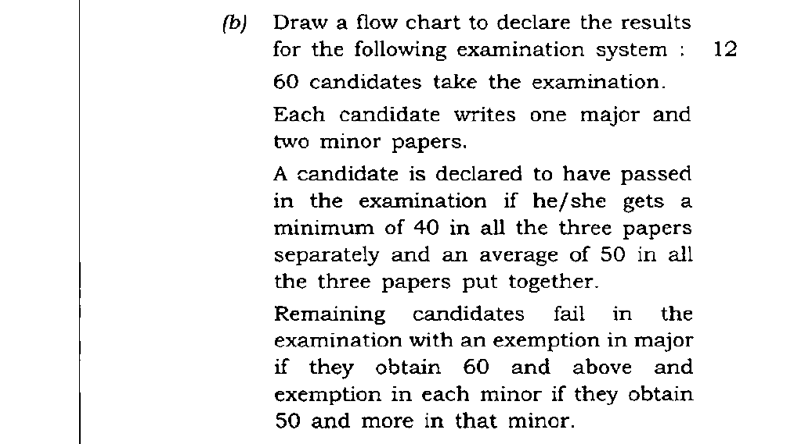

**24. 6b 2010 IFoS**



**ROUGH WORK**